Second method is to configure docker grid is to create a docker-compose file

Docker compose file creation steps

How to create yaml file (for docker composer)

Step 1: Create a folder and navigate to that folder and open the power shell or command window as described below

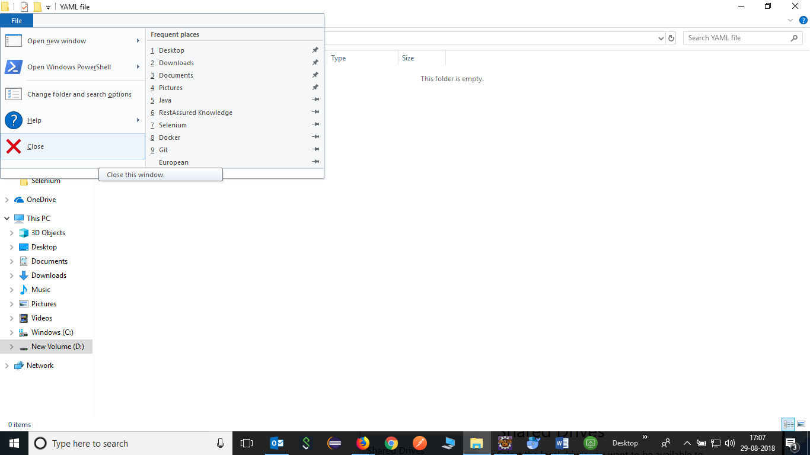

Step 3 : Enter “code .” and press enter and visual studio code window will open.

Note: Visual studio code needs to be installed on system.

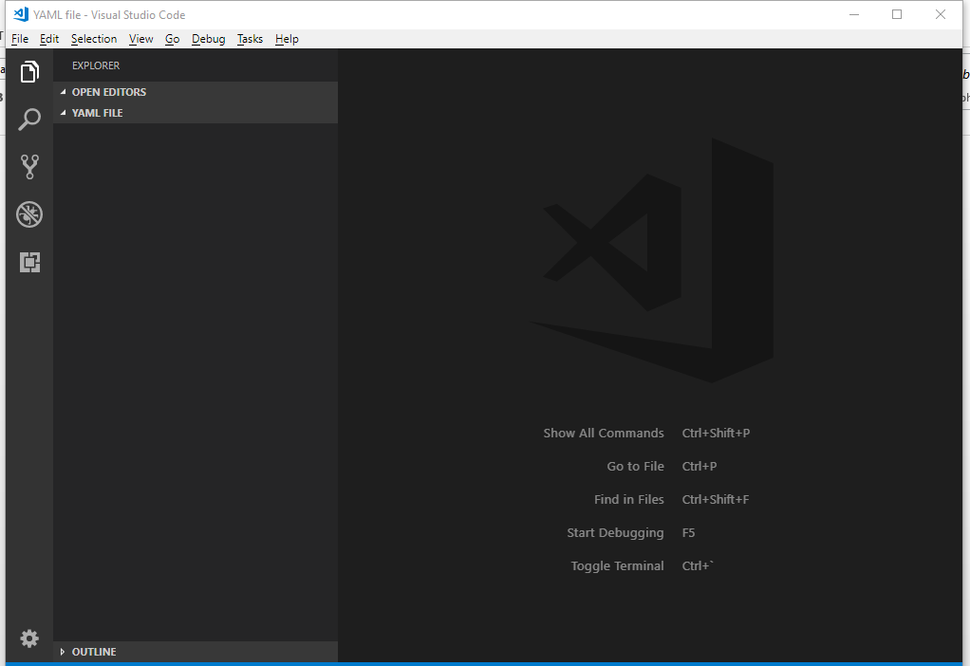

Step 4: Now click on new file button and create the yaml file with .yml file extension.

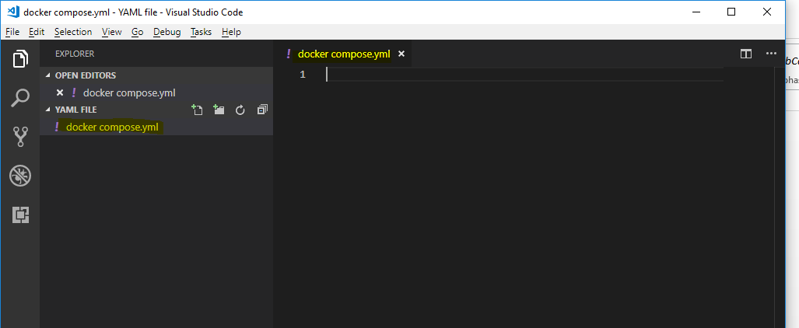

Copy the following contents in above file

seleniumhub:

image: selenium/hub

ports:

- 4444:4444

firefoxnode:

image: selenium/node-firefox-debug

ports:

- 5900

links:

- seleniumhub:hub

chromenode:

image: selenium/node-chrome-debug

ports:

- 5900

links:

- seleniumhub:hub

Note: Take care of spaces in lines of code. Otherwise, the above file will not be executed.

Now again open the command prompt for the .yml file location and issue the following command

$ docker-compose up –d

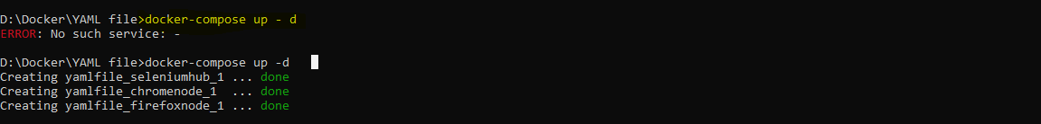

Issue the following command to see above processes are started or not

$ docker-compose ps -a



Now check whether the hub is started or not by issuing the following command

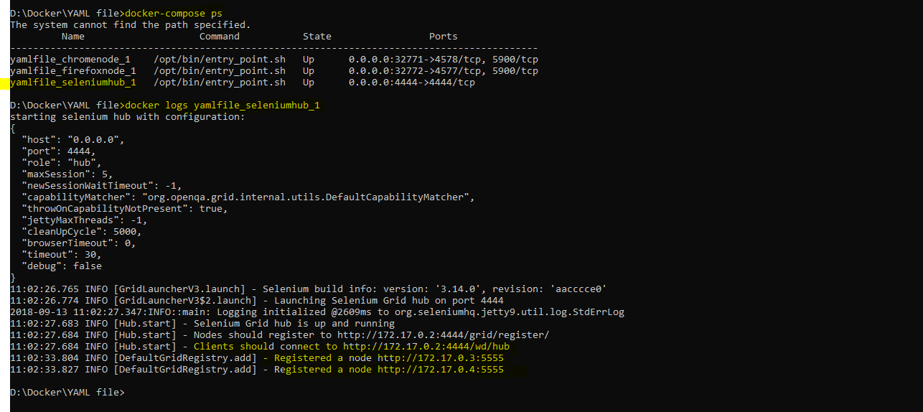

Open browser and hit <http://localhost:4444/grid/console>

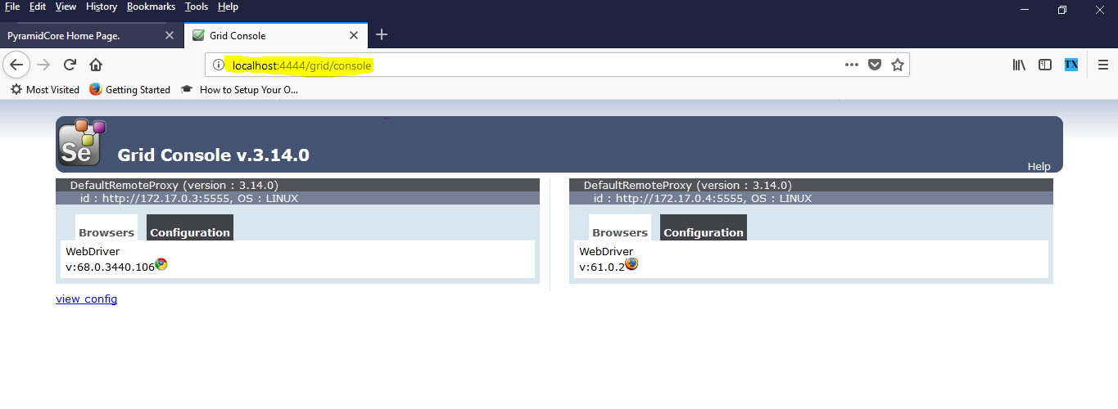

Open VNC and access both containers:

